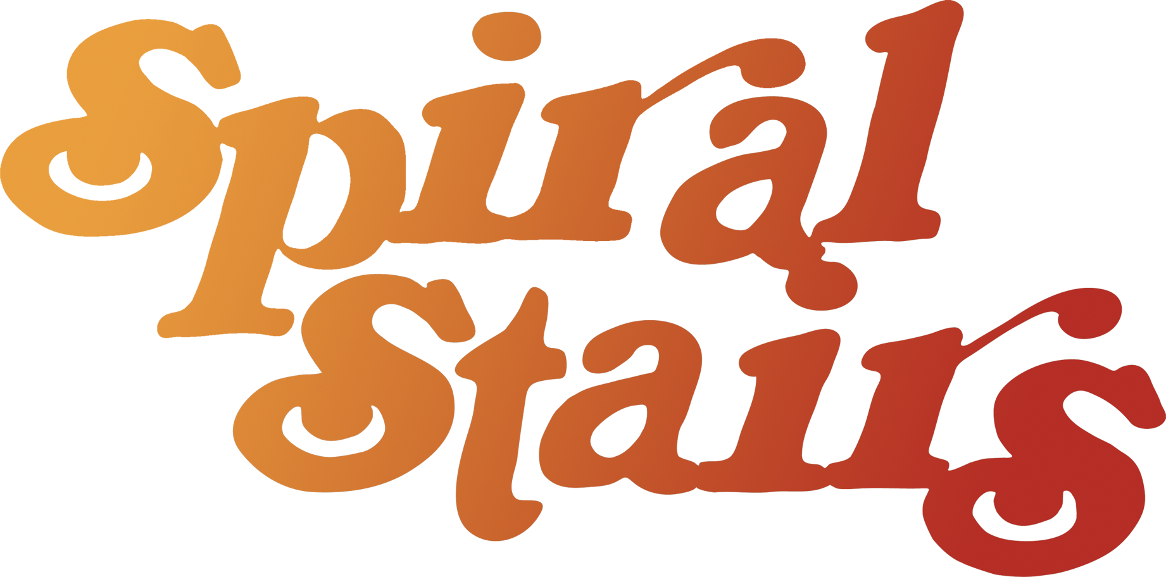
DATE 4/24/2017
VENUE Mississippi Studios
ADDRESS 3939 N Mississippi Ave Portland OR 97227
PHONE (503) 288-3895

DOS CONTACT Zoe Minderovic
DOS PHONE 734-834-1241
DOS EMAIL zoe@mississippistudios.com

DOS SETTLEMENT Arian Dekay
CONTACT PHONE 574-339-9888
CONTACT EMAIL arian@mississippistudios.com

LOAD IN 5:30
CHECK immediately follow load in
SET TIME 10- til
LOAD INSTRUCTIONS Park in the loading zone directly in front of the venue and load through the double doors. Production Manager will issue a parking permit when you arrive and you may remain in the loading zone for the duration of the event.

WIFI NW: MS-PRODUCTION / PW: cookiecookie
HOSPITALITY 2 dressing rooms; main green-room upstairs above merch area / small room back-stage. Headliners receive 1 meal ticket and 2 drink tickets per band/crew member upon arrival. Vegetarian, vegan and gluten free options are available. Support hospitality to be determined day-of-show by production staff based on show budget. Soft drinks, coffee and tea are provided a gratis. Water cooler and cups provided in greenroom.

LODGING Friends………

DISTANCE TO NEXT GIG 3 hours 177 miles
VAN CALL 9 am

