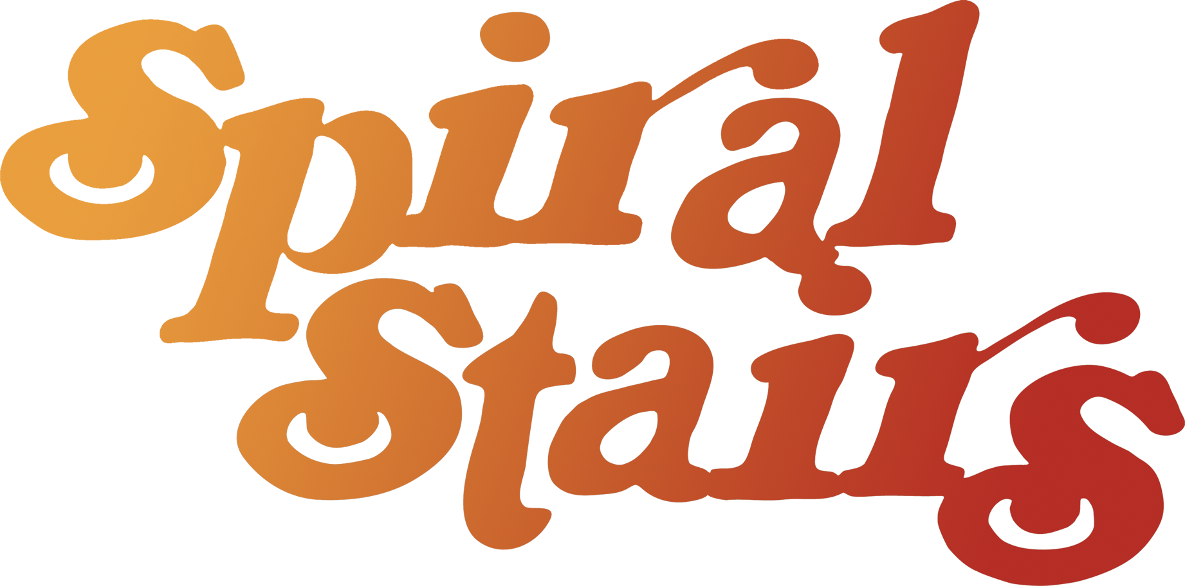
DATE 4/23/2017
VENUE Duffy’s

ADDRESS 337 Main St Chico CA 95928
PHONE (530) 343-7718

DOS CONTACT Jake Sprecher
DOS PHONE 530.864.0232
DOS EMAIL jake@kzfr.org

CONTACT
CONTACT PHONE
CONTACT EMAIL

LOAD IN 6pm
CHECK follow load
SET TIME door 8:30 set at 10:30
LOAD INSTRUCTIONS

WIFI
HOSPITALITY drink tickets

LODGING Quality Inn Near Chico State
715 Main Street,
Chico, CA, US, 95928 Confirmation #: 82406110 Under: Scott Kannberg

DISTANCE TO NEXT GIG 8 hours 495 miles
VAN CALL

