Loading Information
Wisconsin Union Theater

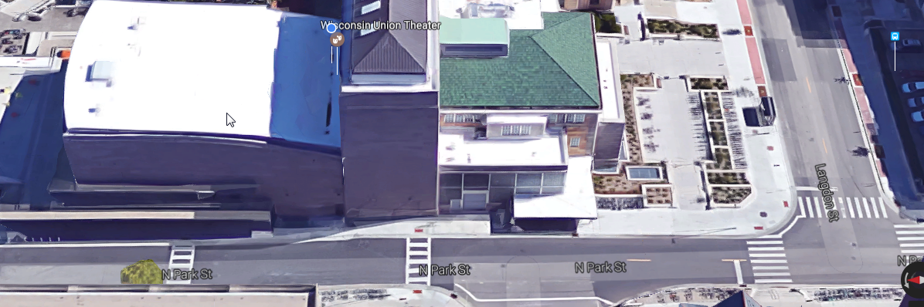
- Please arrange any type of Loading/Unloading with Heather Good, Jeff Macheel, or Heather Macheel, prior to your event.
N. Park St.
Observatory Dr.
Langdon St.
Crosswalks must be kept clear, including 4’ on either side of paint.
Theater Loading Door
Park here with flashers on while loading/unloading. Please plan on moving car after unloading.
- We do not provide parking permits.
- The loading door can be unlocked for tech/performer entrance with prior notice.

